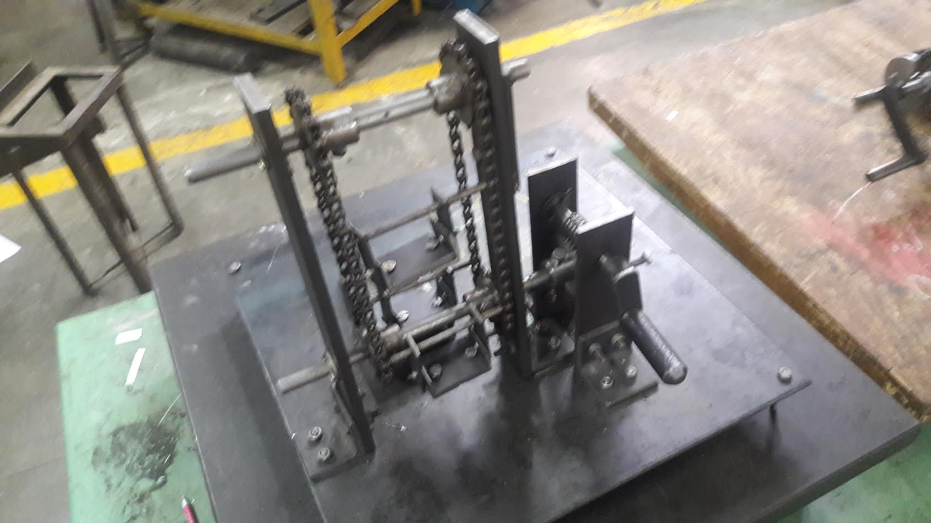

TA202 Project

Smart Car Parking

**INSTRUCTOR - Mr. Sounak Choudhary**

**GUIDE - Mr. HP Sharma**

GROUP 35

* Gurpreet Singh (150259) (C12)
* Abhishek Kumar (150035) (C14)
* Manish Kumar Bera (150381) (C14)
* Tushar Gupta (150770) (C14)
* Dushyant Kumar (150242) (C12)
* Jaskirat Singh (150302) (C12)
* Harshad Yadav (150269) (C12)
* Arjun Sinha (150134) (C12)

# 

# APPENDIX 1 Abstract and Design

# 

# ABSTRACT

Today, the population of the world is increasing to a great extent. In India, the population was thirty six crores only in 1951. Now, this has increased to a hundred and twenty one crores in the year 2011. Since the population rates are heavily increasing, the number of utilities and services provided to them are bound to increase. More population means more vehicles on road, more cars, etc.

Increase in the number of cars asks for larger parking space. The problem of parking space is a very big problem in developing nations. Many people who can afford to buy a car don’t buy it due to the numerous problem associated with it’s parking.

Taking this challenge at hand, our group decided to come up with an idea which can solve this problem to some extent. Our project provides a neat, innovative, creative and practical solution to this problem. In this project, we built a miniature model of a simple mechanism which when implemented with precision on large scale, can handle a large number of parking space problems, thus the name **Smart Car Parking.**

# 

# 

# INTRODUCTION

The Smart Car Parking is a mechanical system designed to minimize the area required for parking cars in a locality or for a particular building. Like a multi-storey parking garage, the Smart Car Parking provides parking for cars on multiple levels stacked vertically to maximize the number of parking spaces while minimizing land usage. The Smart Car Parking, however, utilizes a mechanical system to transport cars to and from parking spaces (rather than the driver) in order to eliminate much of the space wasted in a multi-story parking garage. While a multi-story parking garage is similar to multiple parking lots stacked vertically, the Smart Car Parking is more similar to an automated storage and retrieval system for cars.

The concept for the automated parking system is driven by two factors: a need for parking spaces and a scarcity of available land. According to the current model, the Smart Car Parking can hold three cars in the space meant for two, but the model can easily be extended for accommodating as many cars as necessary.

Mechanically simple with a small footprint, the Smart Parking is easy to use in many places, including inside buildings.

The ever-increasing scarcity of available urban land and increase of the number of cars in use have combined with sustainability and other quality-of-life issues make the Smart Car Parking a relevant alternative to the multi-story parking garages, on-street parking and parking lots in use in today’s world.

# 

# 

# MOTIVATION

In today’s world, space crunch has been a major issue in the society. With the advent of new technology, vehicles are getting cheaper day by day. This is leading to more number of vehicles on the road, and in the households. But, many a times we see that even though people build luxurious apartments and bungalows, they leave little space for car parking. This is a major problem in India, especially in the metros and state capitals. The parking problem has emerged as a major difficulty, and needs to be solved effectively.

It is evident that there is only little space left out for car parking space around buildings. So, our design must be such that it can accommodate as many number of vehicles as possible in the limited ground space. The motivation comes from the structure of apartments. Apartments consume little ground space but accommodate many houses because the design arranges the flats one above the other, in the form of a stack. This design feature allows the houses to consume little ground area, while utilising the overhead space to maximise the number of dwellings.

But, to incorporate this design is a difficult and challenging task. Unlike people who enter the apartments, cars are bigger and rigid. They need more space for mobility to get in and out of the apartment structure. Moreover, a small path must run between parking slots in order to allow cars to get in and out of the parking slots. If the paths are not provided, then the car at the back of the parking lot cannot be moved out without taking out each of the cars placed in front of it. These paths also take up a lot of space, which is not economical.

The design must be in such a way that cars can be stacked one above the other but without providing paths for entry or exit. This leads us to another modification which is inspired from the Ferris wheel. The ferris wheel allows joy riders to enter at only one point, and then rotates the compartments, allowing the next rider to enter into another new compartment. This simple yet elegant design not only allows us to provide one entry and exit point, but also does not stop us from implementing the stacks that we had thought of earlier.

# WORKING AND DESIGN

In this section we will describe the working of the project made by our group.

The design of the smart car parking is inspired from that of the Ferris Wheel, and works on a similar principle. The design allows the user to **stack** the cars one over the other, and thus covering much less ground area than the conventional car parking. But unlike a stack, the design is implemented in such a way that the individual cars can be loaded or unloaded into the structure without causing much inconvenience.

In a Ferris Wheel, the person goes inside a compartment when it is at the ground level, the wheel rotates, then another person gets into another compartment, which is now on the ground level. In a similar fashion, our structure contains car beds, which shall act like compartments of the Ferris Wheel, but instead of holding people, it will hold cars for parking purpose. These car beds will move up and down in a rotatory mechanism, so as to enable loading and unloading of car. When an empty car bed is at the ground level, a car can be loaded into it, which will be followed by moving that bed up so that another empty bed can come to the ground level for car loading purpose. Likewise, when a loaded bed is at the ground level, the car in it can be unloaded, after which the bed will be moved up, to allow another loaded bed can be brought to the ground level for unloading purpose.

We will now discuss about the design details and working of the rotatory mechanism that we implemented in our smart car parking project.

In a Ferris wheel, the compartments are attached to a central shaft with rods that are aligned radially, i.e. , the rods are along the radius. This results in a circular structure. This circular structure rotates about a shaft that is aligned horizontally with respect to the ground. This enables the Ferris wheel for loading and unloading of joy riders into the compartments. Although there is only a single entry point to the structure, the different compartments can be loaded and unloaded by the rotation of the Ferris wheel.

Our mechanism harvests the brilliance of this design. But we customize the design so that it takes up less space. Unlike the Ferris wheel, we implement our mechanism in such a way that the car beds always remain close to the primary supports, so as to minimise space requirement. But this implementation limits us from using radial rods to support the car beds.

So, instead, we attach the car beds to a pair of chains, which move in a conveyor belt fashion, but in vertical direction. Each chain is attached to a pair of sprockets, which are attached to shafts, which are in turn, attached to the main supports. The bottom sprocket is attached to the primary shaft (which receives power from the motor, although indirectly) ; and the top sprocket is attached to the secondary shaft. When the primary shaft is rotated, the chain is forced to move by the bottom sprocket with the help of the auxiliary sprocket that is at the top, thus executing a rotatory motion of the car beds in the vertical direction with respect to the ground.

Now, we will discuss about the mechanism that allows us to rotate the primary shaft, in order to power the rotatory mechanism.

With minimal inspection of the model, one would observe that there may arise a case in which car beds on one side of the shaft are loaded and the other side are not loaded. This would create an imbalance between the two sides of the shaft, which may result in automatic movement of the chains to balance the centre of gravity.

To avoid the above problem, we introduce another mechanism for maintaining stability even in the case of unbalanced centre of gravity. We drive the primary shaft with the help of a worm and worm wheel. The worm wheel is attached to the primary shaft, and the worm is attached to another shaft, which will be driven by an external force (a motor for example). The use of worm and worm wheel prevents the any undesirable rotation of the primary shaft, thus systematically bypassing the above mentioned problem.

# 

# 

# APPENDIX 2 Processes and Costing

# 

# PROCESSES INVOLVED

|  |  |  |
| --- | --- | --- |
| **Part No.** | **Part Name** | **Processes Involved** |
| 01 | Isometric Drawing |  |
| 02 | Base Plate | Shear Cutting, Drilling |
| 03 | Main Frame Support | Shear Cutting, Drilling |
| 04 | Worm Support | Shear Cutting, Drilling |
| 05 | Sprocket Shaft | Cutting, Turning |
| 06 | Worm Shaft | Cutting, Turning |
| 07 | Angle | Shear Cutting, Drilling |
| 08 | Bed Assembly |  |
| 09 | Bed Plate | Shear Cutting, Drilling |
| 10 | Bed Hang | Shear Cutting, Drilling |
| 11 | Bed Support | Shear Cutting, Drilling |
| 12 | Bed Axle | Cutting, Turning |
| 13 | Handle Assembly | Welding |
| 14 | Handle Fix | Cutting, Boring, Tapping |
| 15 | Handle Frame | Cutting, Drilling |
| 16 | Handle Hold | Turning, Cutting |
| 17 | Sprocket | Power Cutting, Turning, Milling, Drilling, Tapping |
| 18 | Worm | Power Cutting, Turning |
| 19 | Worm Gear | Power Cutting, Turning, Milling, Drilling, Tapping |
| 20 | Ramp | Cutting, Welding |

# 

# 

# APPENDIX 3 Isometric and Part Drawings

# 

# INDEX

|  |  |  |  |  |  |
| --- | --- | --- | --- | --- | --- |
| **Part No.** | **Part Name** | **Qty** | **Geometry of Material Required** | **Material Required** | **Dimensions** |
| 01 | Isometric Drawing | 1 |  |  | 450 * 450 * 6 |
| 02 | Base Plate | 1 | Sheet | Mild Steel | 345 * 50 * 6 |
| 03 | Main Frame Support | 2 | Flat | Mild Steel | 180 * 50 * 6 |
| 04 | Worm Support | 2 | Flat | Mild Steel | Ф 12.7 * 230 |
| 05 | Sprocket Shaft | 1 | Rod | Mild Steel | Ф 12.7 * 280 |
| 06 | Worm Shaft | 1 | Rod | Mild Steel | 50 * 50 * 6 |
| 07 | Angle | 4 | Angle | Mild Steel | 50 * 40 * 6 |
| 08 | Bed Assembly | 3 |  |  | 50 * 12 * 3 |
| 09 | Bed Plate | 3 | Flat | Mild Steel | 25 * 25 * 3 * 50 |
| 10 | Bed Hang | 6 | Flat | Mild Steel | 100 * Ф 4 |
| 11 | Bed Support | 6 | Angle | Mild Steel | Ф 25 * 75 * 25 |
| 12 | Bed Axle | 3 | Rod | Mild Steel | Ф 63.3 * 35 |
| 13 | Handle Assembly | 1 |  |  | Ф 22.5 * 105 |
| 14 | Handle Fix | 1 | Rod | Mild Steel | Ф 65.59 * 42.5 |
| 15 | Handle Frame | 1 | Flat | Mild Steel | 16 * 16 * 1.5 |
| 16 | Handle Hold | 1 | Rod | Mild Steel | 450 * 450 * 6 |
| 17 | Sprocket | 4 | Rod | Mild Steel | 345 * 50 * 6 |
| 18 | Worm | 1 | Rod | Mild Steel | 180 * 50 * 6 |
| 19 | Worm Gear | 1 | Rod | Mild Steel | Ф 12.7 * 230 |
| 20 | Ramp | 1 | Sheet | Mild Steel | Ф 12.7 * 280 |

# CALCULATION FOR SPROCKET

Number of Teeth = **14**

Pitch = **0.5”**

Outer Diameter = Pitch x ( 0.6 + cot(180/N) ) = **63.3 mm**

Depth of Tooth = **6.5 mm**

PCD = P/sin(180/N) = **57.07 mm**

# CALCULATION FOR WORM GEAR AND WORM WHEEL

No. of Teeth = **40**

Ratio = **40:1**

Pitch = **4.7 mm**

Outside Diameter = **22 mm**

Face Angle = **60 degrees**

Lead = 4.7 x 1 = **4.7 mm**

Addendum = 0.3183 x 4.7 = **1.49607 mm**

Pitch Diameter of worm = **18.1804 mm**

Depth of worm tooth = **3.22702 mm**

Root Diameter = **15.546 mm**

Pitch Diameter = **59.848 mm**

Centre Distance = **39.0742 mm**

Throat Diameter = **62.840 mm**

Throad Radius = **8.008 mm**

Diameter of wheel over Sharp Corner = **64.986 mm**

Face width = **17.536**

Helix angle = **85.2957**

Thank You !